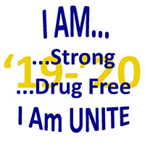
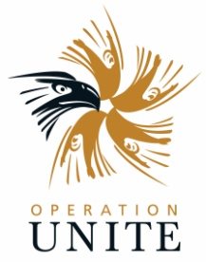
2019-20 UNITE Club
Project/Activity Proposal Form
NOTE: This form is due at time of Club Registration
Club Name: Date:
County / School District:

Please complete all lines that apply. You should submit one form for the entire year at the time your club is registered. Total requests may not exceed $500.00. For all requested expenses you must provide a detailed budget and detailed explanation of need. Do not make any purchases before approval has been given by the UNITE office. This form should be submitted at least one (1) week prior to a UNITE Board meeting (see Manual for meeting dates) for approval.

Food and Beverage -- UNITE funding may not be used for any food or beverage purchases.

1. Office supplies (copy paper, poster board, etc.) (up to $100) _____________________
2. Anti-drug literature and/or materials (up to $100) _____________________
3. Evidence-based or best-practice curriculums (up to $100) _____________________
4. Supplies for youth activities (Provide detailed explanation in space below) ____________________
5. Special speakers for events (up to $150) _____________________
NOTE: Entire club funding cannot be used for special speakers
6. Other (Please specify; will be considered on an individual basis)

Describe each project/activity that relates to above request. Use additional pages as necessary.

Club Sponsor Signature

Download this form at www.operationunite.org. Scan and email to asalyer@centertech.com, Fax to UNITE at 606-889-0874, or mail to: UNITE, 100 Resource Drive, Prestonsburg, KY 41653

