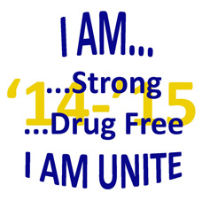
2014-15 UNITE Club Project
of the Month Report Form

Club Name: Date:
County / School District:
Club Sponsor: Phone:
Club President: Club Secretary:
Club Treasurer: Club Historian:
Name of person in charge of project:
Description of project/activity:

Name of project:
Date project took place:
Grade level(s) of students involved:
Total number of students participating:
Community volunteers who participated (if applicable):

Organizations that helped make the project possible (if applicable):

How were UNITE funds used in the project?

Fax this form to UNITE at 606-877-1018 or mail to: UNITE, 350 CAP Drive, London, KY 40744

This form may be downloaded at www.operationunite.org
Page _____ of _____

Name of Grade Service GPA (for
Club Member Level hours seniors)

Duplicate this page as needed
Fax this form to UNITE at 606-877-1018 or mail to: UNITE, 350 CAP Drive, London, KY 40744
This form may be downloaded at www.operationunite.org

