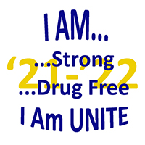
2021-22 UNITE Club
Service Hours Report Form

Club Name: Date:
County / School District:
Club Sponsor: Phone:

This form is to be returned by the Club Sponsor no later than Friday, April 1, 2022, for ALL Club Members (not just senior members) so that record of service can be recorded for the UNITE Club Graduation Honors program.

Name of Grade Service GPA (for
Club Member Level hours seniors)

Continued on next page
Fax this form to UNITE at 606-889-0874 or mail to: UNITE, 110 Resource Court, Suite 101, Prestonsburg, KY 41653
This form may be downloaded at www.operationunite.org.
Page _____ of _____

Name of Grade Service GPA (for
Club Member Level hours seniors)

Duplicate this page as needed
Fax this form to UNITE at 606-889-0874 or mail to: UNITE, 110 Resource Court, Suite 101, Prestonsburg, KY 41653
This form may be downloaded at www.operationunite.org.

