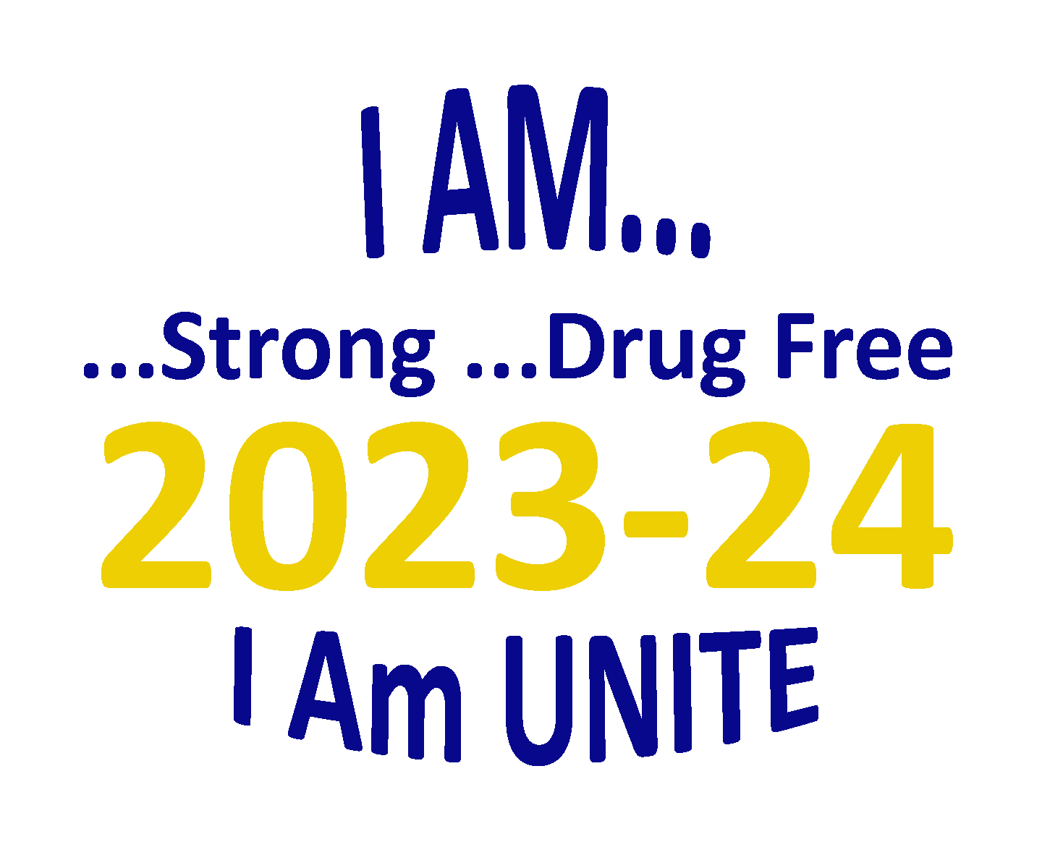

UNITE Club Handbook

2023-24 school year
Updated November 2023

110 Resource Court, Suite 101
Prestonsburg, KY 41653
1-606-889-0422 (Office)
1-606-889-0874 (Fax)
Email: asalyer@operationunite.org

This page is intentionally left blank

Index
UNITE Club Mission Statement 4
Goals for UNITE Clubs 5
Starting A UNITE Club 6
UNITE Club Members 11
Drug-Free Agreement Certificate - Updated 10-27-2023 11
Funding for UNITE Clubs - Updated 10-27-2023 12
Reimbursement 13
UNITE Club T-shirts & Wristbands 15
Promote Your UNITE Club 16
Club and Red Ribbon Week Activity & Event Ideas 19
Organization & Event Tips 25
UNITE Club of the Year - Updated 10-27-2023 26
UNITE Club Graduation Honors 27
UNITE Club Forms
NOTE: Forms are available at bottom of the “UNITE Club” page at OperationUNITE.org
UNITE Club Registration Form 29
Club Member Registration Form 31
Project/Activity Proposal Form - Updated 10-27-2023 33
Monthly Meeting/Activity Report Form 35
Reimbursement/Payment Form 37
Volunteer Service Form 39
Club Service Hours Report Form 41
Staff Resources 43

UNITE Club Mission Statement

UNITE Club members agree to educate themselves and their communities, including youth and their peers, on the importance of remaining drug free, and to help raise awareness about the dangers of substance misuse or abuse, and all the issues that surround drug use, by being a positive, active force in their communities and schools.

U nderstand the forces in our lives that shape attitudes and feelings about drugs
N ever experiment with drugs – Never negotiate our values
I nitiate activities that provide an alternative to drug use

T each others the value of staying drug free
E ncourage peer mentoring in schools
Goals For UNITE Clubs
- To educate young people and the community concerning the physical and psychological effects of tobacco, vaping, alcohol, and other drugs.

- To increase awareness of the diverse and growing number of problems associated with tobacco, nicotine, vaping, and other drug use.

- To train youth to be capable leaders who have a powerful, positive influence on their peers and communities.

- To empower young people to take a lead in developing prevention programs in their schools and communities.

- To provide youth a positive peer support group of friends.

- To foster personal and social responsibility to self and others through educational and service activities.

- To develop the skills necessary to make healthy life choices.

- To become active advocates for drug prevention and inspire others to become partners in tobacco, vaping, alcohol, and other drug prevention efforts.
Starting A UNITE Club
- Identify a sponsor for your UNITE Club.
  - Club Sponsors play a pivotal role in guiding young people toward choosing to stay drug and alcohol free. One simple, effective way you affect young people is by teaching through example.
  - There must be a school staff member or Kentucky AmeriCorps member assigned as the Club Sponsor at all Club functions. A Club Co-sponsor may be someone who is not affiliated with the school.
The Club sponsor’s role includes:
      - Being present at all meetings and events.
      - Helping Club officers plan meetings, activities and arrange events.
      - Delivering or supervising educational activities at Club meetings.
      - Serving as the Club liaison with other adults, UNITE office, UNITE community coalition, and other organizations in the community.
      - Maintaining financial records of funding provided through UNITE.
UNITE Clubs have the ability to make a huge difference, not only in schools, but also in the community. It is because of this that we are looking for highly motivated, enthusiastic, trustworthy, and passionate individuals to help lead and guide these students; the success of the Club rests on the effectiveness of its sponsor.
- UNITE recommends that Clubs be broken down by grades 4-5 (elementary school), grades 6-8 (middle school) and grades 9-12 (high school) because children are often more comfortable around others of the same age. NOTE: If your school goes through 6th grade, Clubs may be broken down by grades 4-5 (lower elementary), grade 6 (upper elementary), grades 7-8 (middle school), and grades 9-12 (high school).
- The more members you have the more people you can reach and the more successful you are likely to be. Make your own flyers, advertise your Club meetings, and invite other students to join. Promote your Club!
- At your first meeting, discuss what the UNITE initiative is and why it is important for everyone to be involved.
- Elect officers
  - UNITE Club President
    - Works with adult leaders and school sponsor to plan activities, meetings and events.
    - Chairs meetings and/or co-chairs with Club Sponsor.
    - Recruits new members.
    - Handles publicity and highlights the Club’s activities.
  - UNITE Club Secretary
    - Keeps minutes of each meeting.
    - Keeps school and other members informed of upcoming meetings and events.
    - Helps publicize upcoming events.
    - Keeps a membership roster (which must be reported to sponsor).
    - Prepares and submits the “UNITE Club Monthly Meeting/Activity Report” form to the UNITE office with assistance of sponsor.
  - UNITE Club Historian
    - Maintains a Club scrapbook.
    - Takes photographs of events and keeps Club sponsor informed of activities.
    - Assists Club sponsor in preparing entry for annual “UNITE Club of the Year” award (submitted at end of school year).
  - UNITE Club Treasurer
    - Collects and records money used by the Club for activities through donations and fundraisers. (NOTE: The Club Sponsor is responsible for maintaining financial records of the funding provided by UNITE.)
- Establish a regular meeting time and place. Club meetings should be held at least monthly during pre-approved school times or in an after-school setting if transportation is provided.
- Once your Club is established you will need to complete and submit the following forms:
  - UNITE Club Registration Form (see Page 29)
  - UNITE Club Member Registration Form (see Page 31)
  - UNITE Club Project/Activity Proposal Form (see Page 33)
ALL CLUBS MUST RE-REGISTER EVERY SCHOOL YEAR.
YOUR CLUB WILL NOT BE ELIGIBLE TO RECEIVE FUNDING UNLESS
THESE 3 FORMS FOR THE 2023-24 SCHOOL YEAR ARE ON FILE.
Be sure to complete all sections of each form. When complete, please email/scan or Fax them to:
Alyson Salyer at asalyer@OperationUNITE.org or 606-889-0422.
- If you have submitted your Club Registration forms but have not heard from Alyson within two weeks, please contact her to verify that we have received your paperwork.
- If submitting by FAX, please follow-up with a phone call or email.
> All activities must be approved by the UNITE Board of Directors before funds can be expended. The UNITE Board of Directors generally meets the 3rd Tuesday of each month. Any activity needing Board approval must be submitted to Alyson Salyer no later than the 2nd Tuesday of each month (one week before Board meeting) so it can be included in the Board report.
Scheduled Board meeting dates (subject to change) are: September 19, 2023; October 17, 2023; November 21, 2023; December 19, 2023; January 16, 2024; February 20, 2024; March 19, 2024; April 16, 2024; and May 21, 2024.
DO NOT make purchases without approval from the UNITE office.
> Registered Clubs may add members throughout the school year, but to be eligible for activity funding and T-shirts (see page 15) Clubs MUST be registered no later than Friday, January 26, 2024.
> Schools may register a Club through Friday, April 19, 2024.
> All Club members registered by Friday, January 26, 2024, will receive a free T-shirt. It is strongly encouraged for Clubs to be registered by the second deadline, Friday, December 1, 2023, to ensure Club members receive T-shirts in January. (For details about ordering see page 15.)
- Develop your UNITE Club’s motto.
- Develop a monthly activity list that outlines your Club’s goals. Use the list of suggested activities in this Handbook to begin thinking about what your Club can do. Feel free to be creative and develop your own ideas.
- Club officers and members are STRONGLY encouraged to become active members of their local UNITE community coalition. This will provide opportunities for partnership and community involvement with your projects and activities.
- Club sponsors are required to submit a “Project/Activity Proposal” form (available in the Forms section and on the “UNITE Club” page at OperationUNITE.org) to the UNITE office for approval AT THE TIME YOU REGISTER YOUR CLUB and BEFORE the project/activity begins or any materials are purchased. This form must have UNITE’s approval.
- If you have submitted a project for Board consideration but have not heard if it was approved within a week after the scheduled Board meeting date please contact Alyson Salyer at asalyer@OperationUNITE.org or 606-889-0422 to check on the status BEFORE spending your funds.
- Clubs are encouraged to keep the UNITE office apprised of your upcoming activities and events. We want to assist you in publicizing your efforts so that you can be an example to the entire community. Plus, UNITE staff may be interested in attending some of these events. Please inform your county’s UNITE Coalition Coordinator. (For a list of coordinators go to the UNITE website OperationUNITE.org. Under the “Programs” tab, click on “Community Coalitions” and then “Coalition Contacts” button.)
- Each UNITE Club is required to submit a “UNITE Club Monthly Meeting/Activity Report” form. (Forms are available at OperationUNITE.org. Click on the “Programs” tab, then “UNITE Clubs” and scroll to the bottom of the page.) Please complete your “Monthly Meeting/Activity Report Form” and email/scan or fax to Alyson Salyer no later than the 2nd Tuesday of each month. This will ensure that your activities are being reported to the Board.
UNITE Club Members

Recruiting Members

Clubs that meet in the schools can be publicized in an array of ways:
• The most effective tool is often peer-to-peer recruitment
• Make announcements over the public address system
• Have teachers make announcements in each classroom
• Give a presentation during a school assembly
• Send letters home to parents/guardians
• Use posters/flyers in hallways, on bulletin boards and newsletters
• Place announcements in local newspaper
Do not be discouraged if the initial turnout for a Club meeting is less than desired. Once the word about the UNITE Club begins to spread, it will help your recruiting efforts.
For more ideas see the “Organization & Event Tips” section (Page 25).

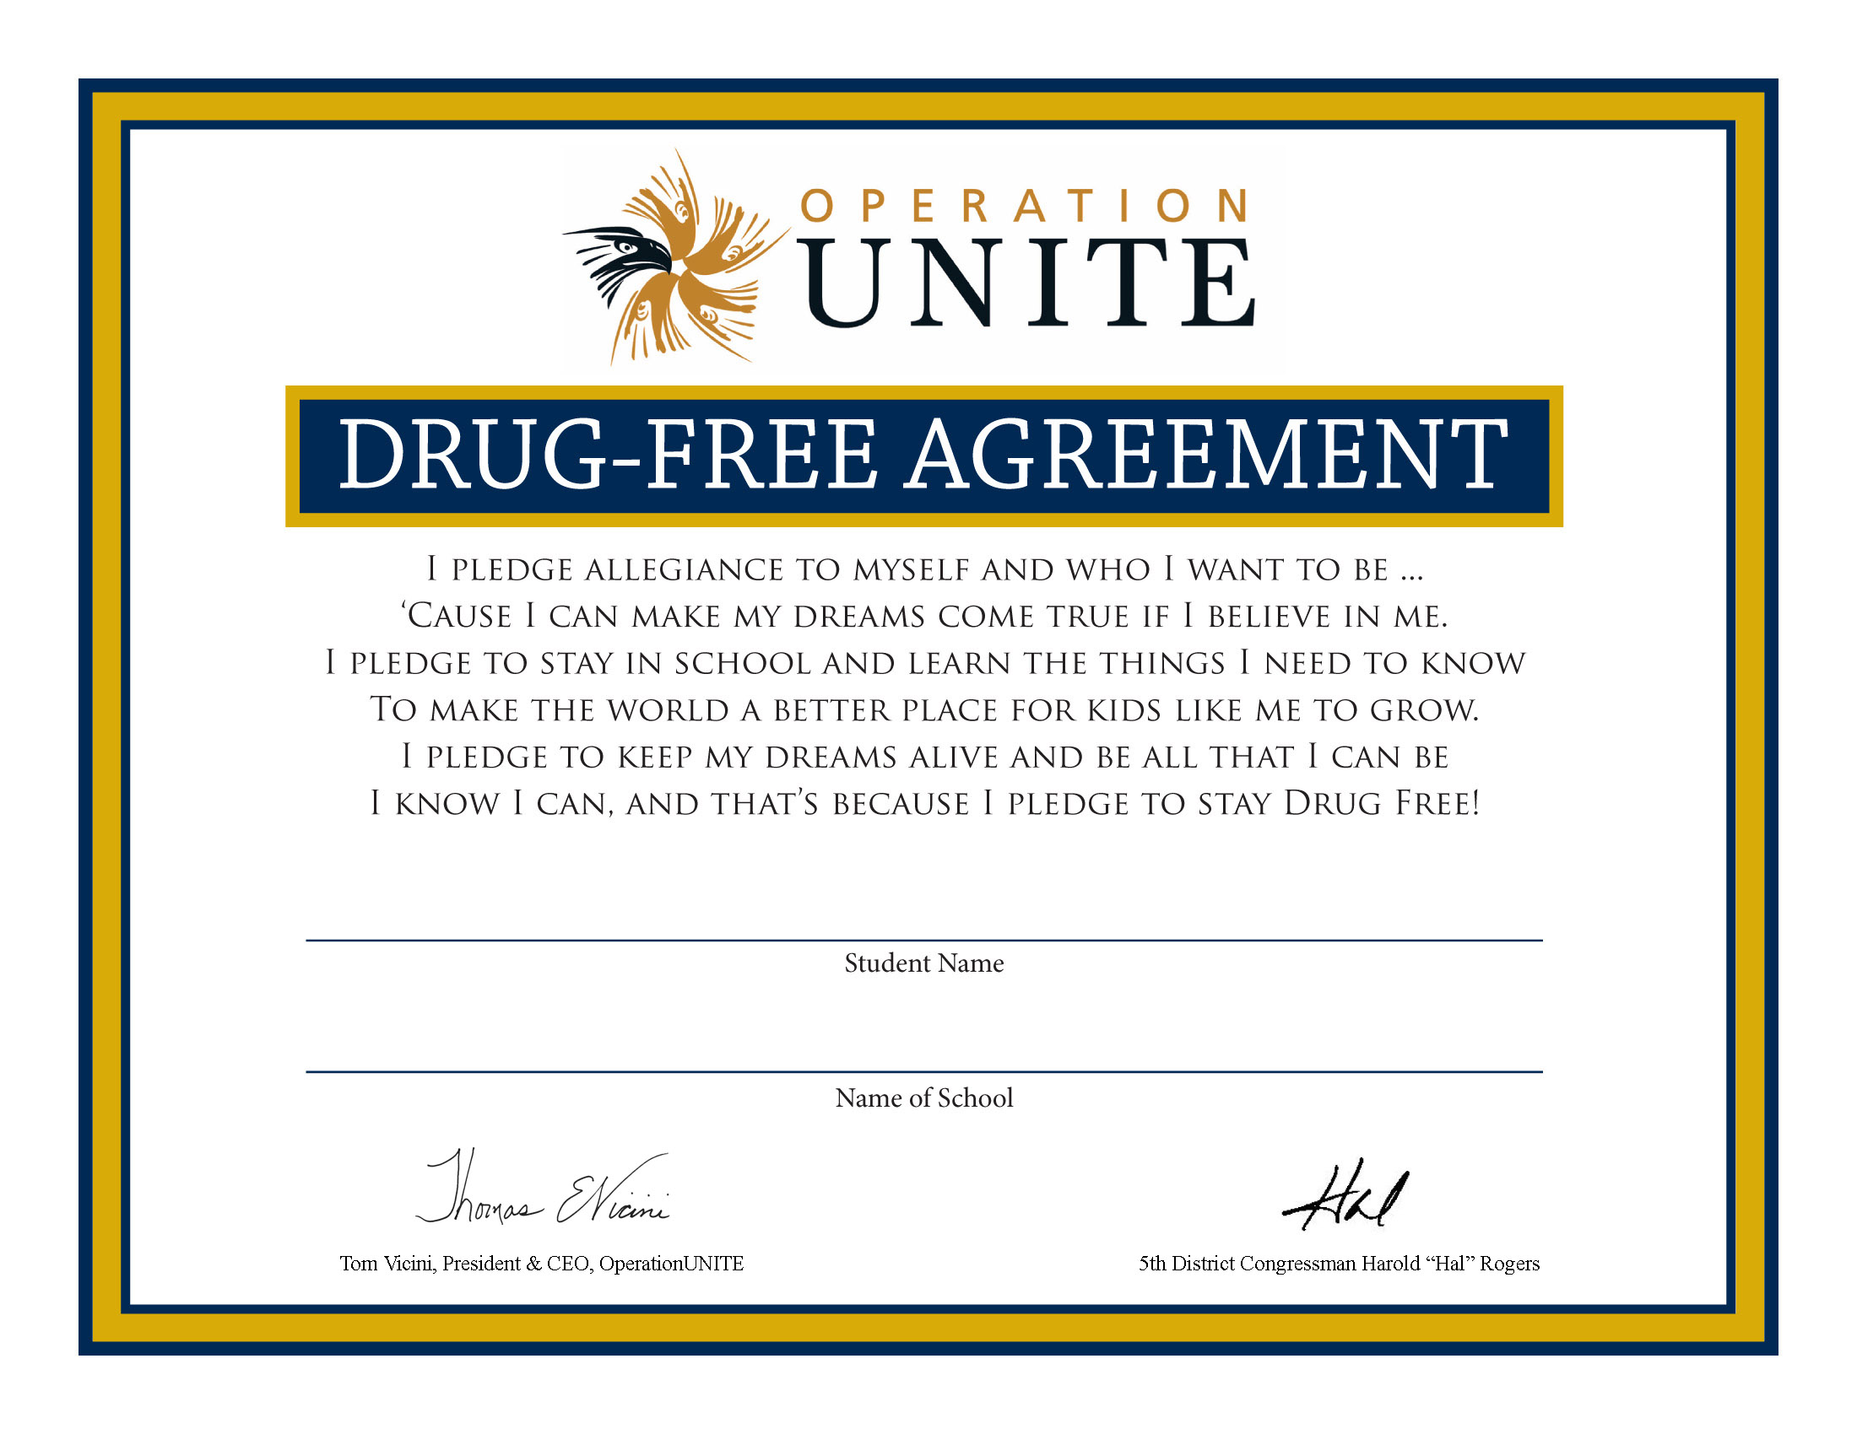
Drug-Free Agreement

UNITE asks that all Club members sign a pledge to be drug free. This 8.5”x11” full-color certificate is available to download on the UNITE Club page at OperationUNITE.org.

No child should be denied membership for any reason, including past drug use or reputation. No one should be asked about his or her drug use in front of other Club members. It is strongly discouraged that anyone discuss past drug use during meetings or elsewhere. The most important consideration is that all members be committed to being drug free.
Funding for UNITE Clubs
Registered UNITE Clubs may receive up to $1,000 from Operation UNITE each school year to assist with projects and activities. These payments are made for allowable resources on a reimbursement basis only.
Clubs may reallocate up to 10% of total approved funds between individual projects without prior approval from UNITE. If more than 10% reallocation is requested, email Alyson Salyer at asalyer@OperationUNITE.org to obtain approval.

Obtain Project Approval
Club registration requirements are outlined in the “Starting A UNITE Club” section (see Page 6 of this manual). Once a UNITE Club is established and registered, all projects and budgets must be submitted and approved by the UNITE office.
Your club will not be eligible to receive funding unless the “UNITE Club Registration,” “UNITE Club Member Registration,” and the “UNITE Club Project/Activity Proposal” forms are completed and on file at the UNITE office.
Do not purchase anything before you have received project approval from the UNITE office.

Acceptable Expenditures
A list of expenses for which UNITE funding may be used is printed on the “Project/Activity Proposal” form.

Non-Acceptable Expenditures
UNITE cannot pay for:
- Lodging or Rent
- Food and beverages
- Field Trips
- T-shirts (UNITE provides shirts for registered UNITE Club members)
- Wages
- Items used in connection with any type of fundraising activity
- Items not specifically for use in connection with UNITE Club activities

PLEASE NOTE: Food and Beverage
UNITE Club funding may not be used for any food or beverage purchases. Please do not request reimbursement for food or beverages from the UNITE office.

Requesting Reimbursement
Once your project/activity has been completed, the Club sponsor should submit detailed copies of any invoice or receipt to support the approved expenses to the UNITE office using the “Reimbursement / Payment Form” (available in the Forms section on page 37 and on the “UNITE Club” page at OperationUNITE.org).
We cannot reimburse you for any purchases without an original receipt from a business or manufacturer.
Requests for reimbursement and associated documentation must be received by Alyson Salyer in the UNITE office no later than Friday, May 31, 2023 for processing.
Clubs may submit requests for reimbursement of approved expenses at multiple times throughout the school year, up to a maximum of $500 per school year.

Direct Payment
Sponsors are encouraged to check whether their school has a policy on establishing a Club account to facilitate payments and reimbursements. Generally, purchase orders can be obtained to cover expenses and the Club benefits from the school’s tax-exempt status. If your school will not allow you to make purchases with a purchase order number, you may do the following using the “Reimbursement Request Form” (available in the Forms section on page 37 and on the “UNITE Club” page at OperationUNITE.org):

• Contact the business you wish to order from and obtain a statement of cost or a quote from the business or manufacturer regarding your purchase. Have it billed to Operation UNITE, 2292 South Highway 27, Somerset, KY 42501.
• Fax or scan your order confirmation along with the details regarding your project that contains the category of approved UNITE Club expenditures (listed on the Project/Activity Proposal Form, page 33), and Reimbursement/Payment Form (page 37) to asalyer@OperationUNITE.org.
• Be sure to include your school’s name on the reimbursement form.
• Your request and statement will be forwarded to our billing office, which will send a check to the business/manufacturer of your items.
• Be sure to include the full name and complete address for the business or manufacturer.
• Be sure to provide the company with YOUR shipping address (no P.O. Boxes) for any items ordered; we will not ship to UNITE offices.
• When payment is received, the business/manufacturer will ship items to the address you have provided.

UNITE Club T-shirts & Wristbands
Operation UNITE will provide an “I AM UNITE” Club T-shirt and wristband for every registered UNITE Club member and up to two (2) Club sponsors. UNITE will pay to have the T-shirts and wristbands shipped directly to your school for the members listed on the “Member Registration” form submitted by your Club during the registration process.
The cost for shipping T-shirts for members added after the original order may be your club’s responsibility.
Registration & Ordering Information
Club T-shirts will be ordered only three times for the 2023-24 school year. All Club registration forms must be submitted before shirts will be ordered.
First registration deadline Friday, October 20, 2023
* Shirts should arrive around Thanksgiving. Highly recommended so your students can show their pride throughout the year!
Second registration deadline Friday, December 1, 2023
* Shirts should arrive shortly after you return from Christmas break
Final registration deadline Friday, January 26, 2024
* Shirts should arrive in mid March
Additional T-shirts for your school, staff and parents will be available for purchase at a cost of $8 per shirt. Orders for additional shirts must be placed on the same order schedule as Club shirts. You will need to send a check, made payable to “Operation UNITE,” to Alyson Salyer at address listed on the cover of this handbook.

All participants agree to indemnify and hold harmless UNITE, its employees, officers, directors and agents, from and against any and all liabilities, obligations, penalties, claims, damages, and/or judgments of any kind, nature or description, including all attorney’s fees and other costs and expenses that may be incurred by UNITE, which may be imposed upon, incurred or suffered by or asserted against UNITE, its employees, officers, directors, and agents by third parties arising out of the recipient’s actions in connection with this project.
Promote Your Club

“I Am UNITE – UNITE Strong” is more than just a theme for your Club; it is a hope that we have for you and your community. In addition, this year’s slogan is: “One Person. One Choice.”
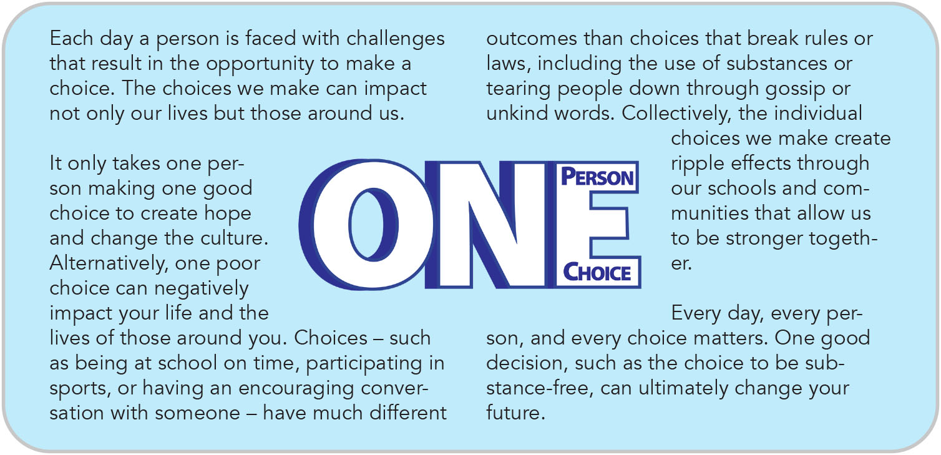
Yes, we have faced obstacles. But we have never lost hope. There are even greater opportunities to promote drug-free lifestyles and engage in service learning projects. UNITE Clubs are needed now, more than ever.

WE ARE UNITE. YOU ARE UNITE. I AM UNITE.

Staying Connected
For Clubs to be successful, they must stay connected. All UNITE Club members are responsible for spreading the word about events and activities within their school and community. Below are a few ideas on how this can be accomplished:

Facebook and Twitter
- Promote your club activities by tagging Operation UNITE on Facebook (@OpUNITEKy), Twitter (@UNITEKy), or Instagram (@operation_unite).
- All Club-related posts should be monitored and approved by the Club Sponsor.
Club Pen Pals
- This idea pairs up UNITE Clubs based on their membership.
- Once paired up, letters could then be written to their Pen Pal Club as a way to broaden horizons and make new friends who may have similar interest or be facing similar problems.
- All correspondence should be monitored by the Club Sponsor for inappropriate content.
Public Service Announcements
- UNITE encourages Clubs to make a Drug Awareness Public Service Announcement – featuring none other than YOU!
- Pick a theme, make a script, and practice (themes/ideas must correspond with the values of UNITE).
- Once ready, Film it!
- Each video can then be edited and compiled to create your own UNITE Club anti-drug PSA.
- All correspondence should be monitored by the Club Sponsor for inappropriate content.
UNITE Reads
- This is a mentoring program based on Rockcastle County’s successful “RocketReaders” Program.
- UNITE Club members are encouraged to pick out books, skits, fun presentations, games, and activities that they can present/teach to elementary-aged kids.
- Have your sponsor arrange times/days that would be acceptable, during school hours, for both you and the kids.
- Remember school comes first - this is just a bonus!
UNITE Club Blog
- Create an on-line blog to share thoughts and ideas or to promote your projects and activities.
- Sponsors should check with school policies before creating blogs and should monitor all postings.
Connect With Other Clubs
- What better way to spread awareness, ideas, and promote your clubs than to connect with other clubs in your school? Plan events together and share ideas.
  - First Priority, Fellowship of Christian Athletes (FCA), BETA, NHS, Thespians Society (Drama Club), etc.
  - For example: Organize an end-of-the-year cookout, sponsor a game together, etc.
Presentations
- Make drug facts presentations that you can present to your classmates that show the dangers of drugs.
- Make presentations at your community UNITE Coalition meetings or other school organizations.
Posters
- Make posters to place around your school that peak interest and raise awareness.
- And remember: Promote your events!
Club and Red Ribbon Week Activity & Event Ideas

To have the greatest impact, you want to involve everyone in your school – students, faculty, staff, and parents – in addition to members of the community. Below are a few suggestions on ways to promote your UNITE Club.

• Logo contest. Give your club an identity. Reward the winner.

• Slogan contest. It is handy to have a catch phrase for use on promotional materials and give focus to your Club’s efforts.

• Take photos at each event and submit to your local newspaper with a brief description of what happened, who was involved, when and where it took place, and the purpose for the event.

• Challenge every Club member to “invite a friend” to become involved. Set a goal for new members and reward the group if they succeed.

• Maintain a hallway bulletin board to display drawings, posters, poems, information about Club activities and anti-drug information. Make sure to include a calendar of upcoming activities. Change monthly.

• Begin each UNITE Club meeting with the Anti-Drug Pledge. (See page 11.)

• Have your school’s cheerleaders learn and perform UNITE-themed cheers.

• Have students write Public Service Announcements and ask local/school radio stations to let members record them. You can also recite them over the school public address system and submit to local radio/TV stations.

• With your sponsor’s permission, create a Facebook or Internet web page with Club activities and photos.

• Organize a school fair about UNITE and dangers of substance abuse. Invite local agencies or representatives that work with substance abuse issues (such as health departments, regional prevention centers, treatment agencies, local law enforcement, and youth clubs).

• Distribute flyers on the dangers of drug use and how to get help.

• Decorate grocery bags with anti-drug messages and redistribute them to the stores in the community. Ask stores to put UNITE Club logo on bags with the school emblem.

• Ask daily substance abuse trivia questions over the intercom.

• Sponsor a UNITE essay contest. (Topic examples: “Why I say NO to drugs” or “How drug use would interfere with my goals.”)

• Have a UNITE poster, poem or song contest.

• Plan UNITE clothing days. Give awards to the class with the most participants:
- “Wear Red Day” – Everyone wears red or red ribbons against drugs (red socks, red hats, and red shirts)
- Hat Day – Everyone decorates hats with anti-drug themes
- Pajama Day – Everyone wears pajamas, house shoes, etc.
- School Spirit Day – See who wears the most school spirit
- Wacky T Shirt-- shirts with buttons and pins that have messages on them
- Face Painting
- Favorite sport day – Everyone dresses up as their favorite athlete
- Shoe of a Kind – kick out drugs – Everyone wears different shoe on each foot
- Celebrity Look Alike – Everyone dresses as their favorite celebrity
- Crazy Hair Day – Everyone wears silly hair styles
- “Give Drugs the Slip Day” – Everyone wears slippers
- “Boot out Drugs Day” – Everyone wears boots
- “Band Against Drugs” – Everyone wears headbands or bandannas
- “Tie Down Drugs Day” – Everyone wears the craziest ties that they can find
- “Don’t Let Drugs Turn You Inside Out Day” – Wear clothing inside out
- “Living Drug-free is no Sweat Day” – Everyone wears sweat clothes
- “Don’t let Drugs Sneak Up on You Day” – Everyone wears sneakers
- “Turn Your Back on Drugs Day” – Everyone wears clothing backwards
- “Shade out Drugs Day” – Everyone wears sunglasses
- “Red Head Day” – Everyone wears something red on his or her heads
- “Dress Up Day” – dress for success
- “Wipe out Drugs”
A. Students wear surfer clothing to school.
B. See how many students you can weave together – over shoulder, through legs – in a single line with rolls of toilet paper

• “Can Drugs” drive – students collect canned soup or other items then donate them to a local shelter or food pantry. This is an especially good project around the holidays.

• Conduct a classroom door decoration contest featuring anti-drug messages.

• Hold drug-free dances and events (such as post-prom/after-graduation).

• Consider collecting donations (such as non-perishable food items and school supplies) for “admission” to activities – even if the event is “free”

• Set up informational booths at fairs, school events, or in school cafeteria.

• Make a video or develop feature story articles about the UNITE Club or substance abuse. Media and/or journalism classes may do feature stories on the effects of substance abuse or related substance abuse issues. Submit to local paper.

• Write and record a song about UNITE.

• Build a chain against drug abuse. Sign your name to a strip of construction paper that you pledge to remain drug free. Link all the strips to make a chain for your club. Display in a prominent location in the school.
Option: “Stand Against Drugs” program – students make a human chain around the hallways or school.

• Make paper bricks; have each student put his or her name on one as a pledge to be drug free. Build a wall to “UNITE to be drug free.”

• Create your own drug-free pledge.

• Organize a pep rally with contests between grades/classes for the best anti-drug cheer.

• “Drugs are Garbage” contest – decorate the trash containers around the school. Also called “Don’t Waste Your Life.” (Permission is required if you want to use permanent markers or paint.)

• Develop and play games, such as trivia contests, Jeopardy or a scavenger hunt with drug awareness themes.

• “Don’t Let Drugs Twist Your Mind” – students hand out snack bags containing pretzels or Twizzlers candy. (Remember UNITE Club funds cannot be used to purchase the candy.) This is a potential activity at lunchtime.

• Invite guest speakers to your meetings to find out what is going on in the community. Some ideas for speakers include:
1. UNITE’s Education Director or staff
2. Your county’s UNITE Coalition Coordinator
3. Mayor, county judge-executive or other elected officials
4. Local agency representative that works in the field of substance abuse
5. Local law enforcement personnel
6. Recovering addict or representative of Drug Court
7. A representative from a treatment center

• Write your federal and state legislators to find out what they are doing on specific drug policies or to show your support for an issue.

• Create a “Hands Off Drugs Wall” – Create a large poster with bare tree branches. Everyone who pledges to be drug-free gets to have their handprint (painted or traced and cut out of paper) with their name placed on the tree as leaves.

• Write and perform a play or skit about effects of drugs or ways to say no.

• Develop a puppet show with the drug-free theme to be performed for younger audience.

• Interview community leaders about UNITE activities in your county and produce a newsletter. This should include articles of interest to readers, plus essays on “Why I Say No”, etc. High school journalism students could mentor elementary students in working on this project.

• Develop an educational presentation to be given at school assemblies, before youth groups, PTA, school board meetings or other groups. This may include drug education, ways to say no, cheers, etc.

• Have a parade before the game or during halftime, carrying drug prevention banners. Invite fellow students to join the parade to demonstrate the strength of your commitment to be drug-free.

• Light candles at halftime of athletic or academic events. Turn off the lights, and spend a moment of silence to remember those students and family members that have lost their lives to drugs. Repeat your pledge to be drug free. Have community or school submit names of those that have lost the battle to substance abuse.

• Build a float with an anti-drug theme for presentation in local parades.

• Develop a lesson about the dangers of drug use and present to a younger class. Resistance strategies – show ways to resist pressure to use drugs:
1. Walk away/leave
2. Give an excuse or a reason
3. Make a joke
4. Hang with others who choose not to use
5. Avoid possible problem situations
6. Say “no” and repeat it again and again if needed
7. Change the subject
8. Ignore it
9. Offer an alternative (a better idea)
10. Have a better idea in mind when asked to use drugs
11. Reverse the pressure: “If you were my friend …”

• Create cartoons illustrating a character using one or more of the strategies above to resist pressure from another character or characters to use alcohol, marijuana, or other illegal drugs.

- Game Day (old-fashioned games)
1. Sit on buckets of ice to freeze out drugs
2. Sack races
3. Tug of war - Have the strength to stay off drugs
4. Corn hole games - Toss drugs out of our lives

Organization & Event Tips

• Choose club events early in the year – there is nothing like having a date on the calendar to keep the planning process moving.
• Club members should decide what projects they are interested in pursuing. Get permission and go for it!
• If possible, hold club meetings weekly. Regular routines afford more interaction, greater visibility, and opportunities for more students to take part.
• When handing out items, be sure to include a tag with contact information for your club, a drug-free message, along with the UNITE Treatment Referral & Help Line (1-866-908-6483), KY HELP Statewide Call Center (1-833-859-4357), and UNITE Drug Tip Line (1-866-424-4382) toll-free numbers.
> A high-resolution logo is available by contacting Dale Morton at dmorton@OperationUNITE.org or 606-271-0624.
• Involve school nurses, counselors, lunchroom staff, bus drivers, custodial workers and central office staff in projects.
• On themed days, reward the classroom with the greatest percentage of participants.
• On the Friday of an anti-drug week celebration reward all students in the school because “they are all winners for being drug-free.” Get local businesses to sponsor. This would be a great Red Ribbon Week activity.
  - Resources to contact for assistance with expenses
    - Family Resource Centers
    - Local chapter of KY-ASAP
    - Family Court, Drug Court or other Specialty Court Judges
    - Police Department or Sheriff’s Office
    - County Attorney
    - UNITE Community Coalitions
• Looking for speakers? Start within your school. Parents and guardians are involved in many professions; grandparents offer an interesting glimpse of times past. This could also be a demonstration or musical performance. Conclude by discussing how drugs interfere with being able to perform or enjoy these various hobbies and job activities.
• Don’t be afraid to elect UNITE Club officers who have never before led a Club or sports team. Remember: Involve everyone!
• To get the biggest impact at the lowest cost, partner with other school clubs when holding events in your community.
• Invite community and business leaders to serve as judges for contests. This promotes awareness and encourages more people to become involved with your school.
• Ask parents and businesses to donate gifts for prizes and food items for Club events.
• Don’t rely on just one awareness promotion. Keep the message current by attending lots of school academic and athletic events (especially football, basketball, soccer and baseball contests) and distribute handouts. Remember you are trying to reach everyone, so mix up your audience. You will also spread the word to other schools!
• Utilize hands-on projects and make sure Club members – not only the sponsors – are responsible for the planning process.
• Be sure to send thank-you notes to anyone who helps your Club.
• Make your event interesting with a special slogan or theme.
• Keep a scrapbook. Include copies of forms, activity directions, meeting minutes and other items. Not only will it provide memories, but you will have a ready-made source of ideas and a visual guide for future club members and new sponsors.

UNITE Club of the Year
Scrapbooks are used to determine UNITE Club of the Year award winners. Involve all club members in this project. Winning clubs can receive up to an additional $1,000 for activities during the next school year. A scoring matrix is available on the UNITE Club webpage.
Scrapbooks should be turned into UNITE by Friday, May 31, 2024.
UNITE Club Graduation Honors
So you’re a member of your school’s UNITE Club. AWESOME! Now let’s take it that extra mile. By completing the following criteria, high school seniors may receive the following honors:
- Induction as a “UNITE Ambassador,” commemorated by a Certificate
- A letter of recommendation from UNITE to the college of your choice
- Become eligible for an “I Am UNITE” Scholarship (Application guidelines for the scholarship will be sent to your Club sponsor and posted at OperationUNITE.org around February 1.)
Criteria
To be eligible for UNITE Club Graduation Honors you must:
1. Have an average cumulative GPA (grade point average) of 2.75
2. Participate in a minimum number of volunteer hours (documented on the “Volunteer Service” and “Service Hours Report” forms available in the Forms section or on the UNITE Club page at OperationUNITE.org) by the end of your senior year based upon the number of years you have been a club member:
• One-year member (this year’s seniors) – complete 25 hours.
• Two-year member – complete 50 hours.
• Three-year member – complete 75 hours.
• Four-year member – complete 100 hours.
NOTE: Rising seniors can obtain approximately 60 hours of volunteer work by serving as a Team Leader or Junior Team Leader at Camp UNITE. (These positions are determined through an annual application process.)
Application forms are available in the early spring on OperationUNITE.org.

This page is intentionally left blank

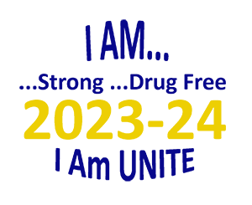
2023-24 UNITE Club
Registration Form

NOTE: The deadline to register a UNITE Club and receive funding is Friday, January 26, 2024.

Name of School: Date:
Club is for grades (check all that apply): ___4th ___5th ___6th ___7th ___8th ___9th ___10th ___11th ___12th
School Address: County
City State: ZIP
School Phone: Fax:

Club Sponsor:
Preferred Phone: E-mail:
Best way to contact: Phone ___ E-mail ___ Text ___
Club Sponsor:
Preferred Phone: E-mail:
Best way to contact: Phone ___ E-mail ___ Text ___
Number of Club Members: Total number of T-shirts needed (incl. sponsors)
Each Club member and Sponsor (maximum 2 sponsors) receive one (1) shirt per club registration. Additional shirts may be purchased for $8 each. (See details in UNITE Club Handbook.)
Please tally your Club’s TOTAL T-shirt order (from Member Registration Form plus sponsors):
YS _____ YM _____ AS _____ AM _____ AL _____ XL _____ 2XL _____ 3XL _____
Captain: Secretary
Treasurer: Historian

Please submit your UNITE Club’s proposed ideas:

Please provide tentative information on your club meeting dates and times:

Download this form at OperationUNITE.org. Scan then email to asalyer@OperationUNITE.org, Fax to UNITE at 606-889-0874, or mail to: UNITE, 110 Resource Court, Suite 101, Prestonsburg, KY 41653

This page is intentionally left blank

2023-24 UNITE Club
Member Registration

Please fully complete student information for each UNITE Club member and submit to the UNITE office with your Club Registration and Project/Activity Forms. You may add new members at anytime during the school year, but T-shirts are not available after the final registration deadline.

NOTE: The deadline to register a UNITE Club is Friday, January 26, 2024.
No clubs will be funded following this date.

Club Name: Date:
Name of School:
County:_______________________________________________________________________________

Club Sponsor: T-shirt size:
Club Sponsor: T-shirt size:

Student’s Name: Grade: T-shirt size:
Student’s Name: Grade: T-shirt size:
Student’s Name: Grade: T-shirt size:
Student’s Name: Grade: T-shirt size:
Student’s Name: Grade: T-shirt size:
Student’s Name: Grade: T-shirt size:
Student’s Name: Grade: T-shirt size:
Student’s Name: Grade: T-shirt size:
Student’s Name: Grade: T-shirt size:
Student’s Name: Grade: T-shirt size:

Continued on next page

Page _____ of _____

Student’s Name: Grade: T-shirt size:
Student’s Name: Grade: T-shirt size:
Student’s Name: Grade: T-shirt size:
Student’s Name: Grade: T-shirt size:
Student’s Name: Grade: T-shirt size:
Student’s Name: Grade: T-shirt size:
Student’s Name: Grade: T-shirt size:
Student’s Name: Grade: T-shirt size:
Student’s Name: Grade: T-shirt size:
Student’s Name: Grade: T-shirt size:
Student’s Name: Grade: T-shirt size:
Student’s Name: Grade: T-shirt size:
Student’s Name: Grade: T-shirt size:
Student’s Name: Grade: T-shirt size:
Student’s Name: Grade: T-shirt size:
Student’s Name: Grade: T-shirt size:
Student’s Name: Grade: T-shirt size:
Student’s Name: Grade: T-shirt size:
Student’s Name: Grade: T-shirt size:

Duplicate this page as needed

Download this form at OperationUNITE.org. Scan then email to asalyer@OperationUNITE.org, Fax to UNITE at 606-889-0874, or mail to: UNITE, 110 Resource Court, Suite 101, Prestonsburg, KY 41653
2023-24 UNITE Club
Project/Activity Proposal Form
NOTE: This form is due at time of Club Registration

Club Name: Date:
County / School District:

Please complete all lines that apply. You should submit one form for the entire year at the time your club is registered. Total requests may not exceed $1,000.00. For all requested expenses you must provide a detailed budget and detailed explanation of need. Do not make any purchases before approval has been given by the UNITE office. Be aware that proposed Club activities must be approved by the UNITE Board of Directors (see UNITE Club Handbook for additional details and meeting dates).

Club funding MAY NOT be used for any food or beverage purchases
1. Office supplies (copy paper, poster board, etc.) (up to $100) _____________________
2. Anti-drug literature and/or materials (up to $100) _____________________
3. Evidence-based or best practice curricula (up to $100) _____________________
4. Supplies for youth activities (Provide detailed explanation in space below) ____________________
5. Special speakers for events (up to $150) _____________________
NOTE: Entire club funding cannot be used for special speakers
6. Other (Please specify; will be considered on an individual basis)

Describe each project/activity that relates to above request. Use additional pages as necessary.

Club Sponsor Signature

Download this form at OperationUNITE.org. Scan then email to asalyer@OperationUNITE.org, Fax to UNITE at 606-889-0874, or mail to: UNITE, 110 Resource Court, Suite 101, Prestonsburg, KY 41653

This page is intentionally left blank

2023-24 UNITE Club Monthly
Meeting/Activity Report Form

Club Name: Date of report:
School Name: Report for month of:
County / School District: # of activities for month:
Club Sponsor: Phone:
Please send this form MONTHLY to Alyson Salyer at asalyer@OperationUNITE.org
The UNITE office wants to include your ideas and share information with other clubs across the region. Send photos whenever possible, along with a copy of this form, to: dmorton@OperationUNITE.org so we can showcase on UNITE’s social media sites.

Name of activity:
Date(s) of activity: Total number of participants:
Description of activity (Include: Who was involved? What exactly took place during the activity? Where was the event held? Explain how your school/community benefitted from the activity. What were the long-term benefits?):

Name of activity:
Date(s) of activity: Total number of participants:
Description of activity (Include: Who was involved? What exactly took place during the activity? Where was the event held? Explain how your school/community benefitted from the activity. What were the long-term benefits?):

Name of activity:
Date(s) of activity: Total number of participants:
Description of activity (Include: Who was involved? What exactly took place during the activity? Where was the event held? Explain how your school/community benefitted from the activity. What were the long-term benefits?):

Download this form at OperationUNITE.org. Scan then email to asalyer@OperationUNITE.org, Fax to UNITE at 606-889-0874, or mail to: UNITE, 110 Resource Court, Suite 101, Prestonsburg, KY 41653

This page is intentionally left blank

2023-24 UNITE Club
Reimbursement / Payment Form

Club Name: Date:
County / School District:
Club Sponsor: Phone:
Reimbursement: When your project/activity is complete, submit this form, along with proper documentation (original invoices, purchase orders, packing slips, etc.) to support the approved expenses for processing. Documentation must include the name of the vendor, date of purchase and dollar amount. All requests for reimbursement must be received by the UNITE office by Friday, May 31, 2024.
Direct Payment: If you need to have UNITE pay for approved expenses directly, see page 13 of Club Handbook for details and submit a copy of your order confirmation to Alyson Salyer at asalyer@OperationUNITE.org.

ITEM OF EXPENSE COST
TOTAL AMOUNT REQUESTED
Make check payable to:
Mail check to this address:
Name of person submitting this report:
Contact phone number: E-mail:
Date report completed: Signature:

Download this form at OperationUNITE.org. Scan then email to asalyer@OperationUNITE.org, Fax to UNITE at 606-889-0874, or mail to: UNITE, 110 Resource Court, Suite 101, Prestonsburg, KY 41653

This page is intentionally left blank

2023-24 UNITE Club
Volunteer Service Form

This is to document that _______________________________________________, a ______ grade student and member of the _______________________________________________ UNITE Club, has performed the following volunteer service hours during the 2023-24 school year.

Name of the organization or group for which volunteer service was performed:

Describe type of volunteer service performed:

Total Volunteer Service Hours: ____________________

Signature of organization or group representative Date

Name of the organization or group for which volunteer service was performed:

Describe type of volunteer service performed:

Total Volunteer Service Hours: ____________________

Signature of organization or group representative Date

Download this form at OperationUNITE.org. Scan then email to asalyer@OperationUNITE.org, Fax to UNITE at 606-889-0874, or mail to: UNITE, 110 Resource Court, Suite 101, Prestonsburg, KY 41653

This page is intentionally left blank

2023-24 UNITE Club
Service Hours Report Form

Club Name: Date:
County / School District:
Club Sponsor: Phone:

This form is to be returned by the Club Sponsor no later than Friday, March 29, 2024, for ALL Club Members (not just senior members) so that record of service can be recorded for the UNITE Club Graduation Honors program.

Name of Grade Service GPA (for
Club Member Level hours seniors)

Continued on next page

Download this form at OperationUNITE.org. Scan then email to asalyer@OperationUNITE.org, Fax to UNITE at 606-889-0874, or mail to: UNITE, 110 Resource Court, Suite 101, Prestonsburg, KY 41653

Page _____ of _____

Name of Grade Service GPA (for
Club Member Level hours seniors)

Duplicate this page as needed

Download this form at OperationUNITE.org. Scan then email to asalyer@OperationUNITE.org, Fax to UNITE at 606-889-0874, or mail to: UNITE, 110 Resource Court, Suite 101, Prestonsburg, KY 41653

Staff Resources

For assistance with UNITE Club questions:

Alyson Salyer
Coalition & Education Coordinator
1-606-889-0422 (Office)
1-606-794-9220 (Work Cell)
1-606-889-0874 (Fax)
asalyer@OperationUNITE.org

or

Debbie L. Trusty
Education Director
1-606-889-0422 (Work Cell)
dtrusty@OperationUNITE.org

If your UNITE Club would like information about bringing

UNITE’s “On The Move!” education initiative to your school,

or scheduling a “Life With A Record” (7th grade and above),

“W.I.S.E.” (grades 4-6), “The Truth About Vaping” (middle and high), or

“Freedom over Fentanyl” (middle and high) presentation

for your school or club, contact:

Courtney Maynard
Prevention Programs Coordinator
1-606-636-7227 (Work Cell)
cmaynard@OperationUNITE.org

OperationUNITE.org

